1. Name any one domestic animal that gives us milk.

_______________________________________________________________________________

1. Give any one characteristic of insects.

_______________________________________________________________________________

1. Write any one way of saving energy at home.

_______________________________________________________________________________

1. Which disease vector is controlled by draining stagnant water?

_______________________________________________________________________

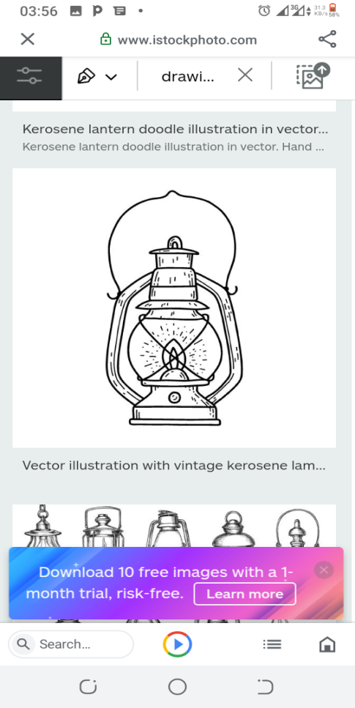 **The diagram below shows a domestic item. Use it to answer questions 5 and 6.**

1. Identify the domestic item shown above.

_______________________________________________________________________________

1. Which fuel does the shown item use?

_______________________________________________________________________

1. Mention any one property of air.

_______________________________________________________________________________

1. Write any one way one can care for his/her crops in a garden.

_______________________________________________________________________________

1. Why do people boil water for drinking?

_______________________________________________________________________

**The diagram below shows an insect. Use it to answer questions 10 and 11.**

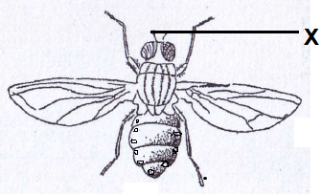

**Y**

1. Name the part labeled with letter Y.

______________________________________________________________________________

1. What is the use of part X to the insect?

_______________________________________________________________________

1. Give the best food for new born babies.

_______________________________________________________________________________

1. Which part on a mosquito does it use to make sound?

_______________________________________________________________________

1. Identify any one garden tool used for weeding.

_______________________________________________________________________________

1. Name the female part of a flower.

_______________________________________________________________________________

1. Mention one common accident at home.

_______________________________________________________________________________

1. Draw the sharp object named below.

**Broken bottle**

1. How does a cow communicate when it needs help?

_______________________________________________________________________

1. Give any one advantage of using electricity to cook.

_______________________________________________________________________________

1. Name the vector that spreads plasmodia to people.

_______________________________________________________________________________

1. State any one product obtained from clay as a natural material.

_______________________________________________________________________________

**The diagram below shows a garden equipment commonly used in rural areas. Study it and use it to answer questions 22 and 23.**

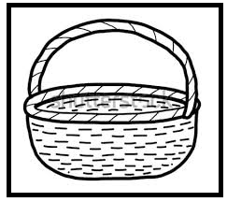

1. Identify the garden equipment shown above.

_______________________________________________________________________________

1. Give one use of the above equipment to family members.

_______________________________________________________________________________

1. ________________________________is the arrangement of soil layers from top to bottom.
2. Write down any one place where animals live.

_______________________________________________________________________________

1. What term is used to mean the insects which do not live, move or work together?

_______________________________________________________________________

1. Mention the kind of weather which is good for winnowing.

_______________________________________________________________________________

1. Which group of living things makes its own food?

_______________________________________________________________________

1. Why is AIDS said to be a deadly disease?

_______________________________________________________________________

1. State the use of structures labeled M on the plant below.

_______________________________________________________________________________

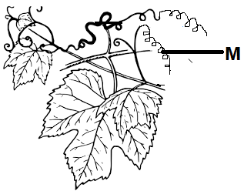

1. Name the structures labeled M.

_______________________________________________________________________________

1. Write down one use of water on the farm.

_______________________________________________________________________________

1. State the part of a bird that keeps it warm during cold weather.

_______________________________________________________________________________

1. Mention any one way of making soli fertile.

_______________________________________________________________________________

1. Suggest the type of bees which lay eggs in the hive.

_______________________________________________________________________________

1. Give one effect of accidents to a casualty.

_______________________________________________________________________________

1. Mention any one natural source of energy.

_______________________________________________________________________________

1. Study the garden tool below and state its use on a farm.

_______________________________________________________________________________

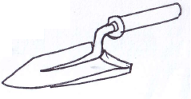

1. Write down one condition needed for germination to take place.

_______________________________________________________________________________

1. Give one item used to make ORS.

_______________________________________________________________________________

**SECTION B (60 MARKS)**

1. **Read the passage below and answer the questions about it.**

Germs are tiny organisms which cause diseases. Cholera, diarrhea, malaria, dysentery and bilharzias are some of the diseases caused by germs.

Germs are found in dirty places such as; dust, toilets, rubbish pit, latrines, dirty food etc.

Germs can only be seen by a microscope.

**By I J Akuku P.3 B.**

1. What is the passage about?

_______________________________________________________________________

1. Why are germs bad according to the passage?

_______________________________________________________________________

1. Give one disease that is caused by germs.

_______________________________________________________________________________

1. Name the instrument used to see germs.

_______________________________________________________________________________

1. **The diagram below shows how diseases can spread through the 4 Fs. Use it to answer questions that follow.**

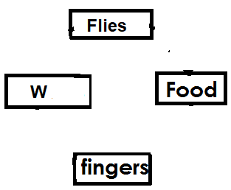

1. Give the word which should be in the box marked W.

­­­­­­­­­­­­­­­­­­­­­­­­­­­­­­­­­­­­_______________________________________________________________________________

1. How does a housefly spread diseases through food?

_______________________________________________________________________

1. Mention two activities which can be done to avoid the spread of diseases through food.

_______________________________________________________________________________

1. (a)Give the use of these parts of a bird.

(i)beak _______________________________________________________________________

(ii)spur ________________________________________________________________________

(b)Name one example of poultry.

_______________________________________________________________________________

(c)Write down one example of a poultry product.

_______________________________________________________________________________

1. Tick four ways of controlling rusting in metals.

blowing painting enameling

draining washing sharpening

fencing galvanizing greasing

1. 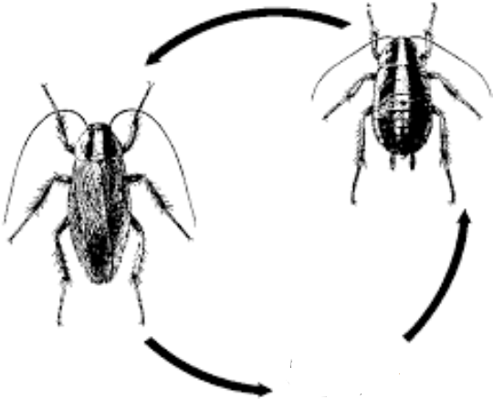**The diagram below shows a lifecycle of an insect. Use it to answer the questions that follow.**

**P**

**S**

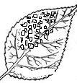

**Eggs**

1. Identify the insect with the life cycle shown above.

_______________________________________________________________________________

1. State the names of the stages marked;

(i)P ___________________________________________________________________________

(ii)S ___________________________________________________________________________

1. What type of life cycle is represented above?

_______________________________________________________________________

1. **Underline the odd member I each list.**

|  |  |  |  |
| --- | --- | --- | --- |
| **A** | **B** | **C** | **D** |
| mosquito  housefly  bee  cockroach | room  clay  loam  sand | feeler  head  thorax  tail | bilhaziasis  yellow fever  bubonic plague  mosquito |

1. **Read and write correct or incorrect about clay soil.**
2. Particles are loosely spaced
3. It has humus
4. It drains water slowly
5. It has large air spaces.
6. (a)What is energy?

___________________________________________________________________________________________________________

(b)Write down three examples of fuels.

_______________________________________________________________________________

1. **Use the diagram below to answer the questions that follow.**

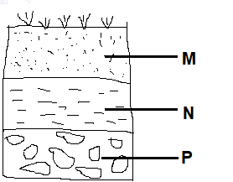

1. Name the layers marked;

(i)P ___________________________________________________________________________

(ii)N ___________________________________________________________________________

1. Why is layer M said to be good for crop growth?

_______________________________________________________________________

1. What does the above diagram show about soil?

_______________________________________________________________________

1. (a)Define the term first aid.

_______________________________________________________________________________

(b)Give two importance of giving first aid to an injured person.

_______________________________________________________________________________

(c)Identify any one tool found in a first aid box.

_______________________________________________________________________________

1. **Match these animals to their movement patterns.**

**Animal Movement.**

Fish walking

Caterpillar wriggling

Cat flying

House fly swimming

(i)Fish ________________________________________________________________________

(ii)Caterpillar __________________________________________________________________

(iii)Cat ________________________________________________________________________

(iv)House fly ___________________________________________________________________

1. (a)What is meant by the term dehydration?

_______________________________________________________________________

(b)Give any two signs which show that one is dehydrated.

(i)_____________________________________________________________________________

(ii)_____________________________________________________________________________

(c)Mention any one way you can treat a dehydrated person.

_______________________________________________________________________________

1. **The table below shows diseases, the vector that spreads them and the disease causing germs. Study it and complete it correctly.**

|  |  |  |
| --- | --- | --- |
| **Disease** | **Vector** | **Germ** |
| Elephantiasis | ______________________ | Filarial worm |
| Typhoid | House flies | _____________________ |
| ______________________ | Rat fleas | Bacteria |
| Yellow fever | _________________________ | virus |

1. (a)What do you understand by manmade changes?

_______________________________________________________________________

(b)State any two man made changes.

_______________________________________________________________________________

(c)How is too much sunshine dangerous to our environment?

_______________________________________________________________________

1. (a)What is air?

_______________________________________________________________________

(b)Why does a candle stop burning when covered in a glass?

_______________________________________________________________________

(c)Name the property of air shown below.

_______________________________________________________________________________

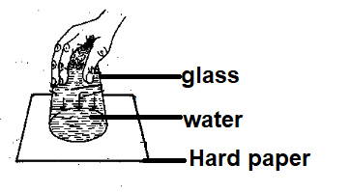

(d) Mention the component of air with the highest percentage.

______________________________________________

**END.**